**Project Title: FoodFort**

1. **Introduction**

The objective of this project is E-commerce solution to the café DrinkLab, Mangalore. The main goal of this system is to enable the customer an easy food ordering experience. The customer will be able to order food at his/her convenience without having to visit the café. The admin will receive the orders placed by the customers. The admin will be able to add items if any new items are available. The admin will be able to modify the available items.

Since the number of orders are increasing day by day, management of orders through phone calls or text messages is too difficult for the manager, hence this web application would be very helpful and smoothen the whole process. Also, the customer will experience and amazing and easy food ordering experience.

1. **Design and Implementation**

Since this application required E-commerce based solution, PHP and MySQL was chosen as the backend technologies of the website. To implement quick front-end development, Bootstrap 4 was used as the CSS framework and lot of other CSS libraries were used which will be discussed below.

Libraries and tools used:

1. OwlCarousel: OwlCarousel is a jQuery plugin used to implement Carousel sliders in the web application.
2. Animate.css: Animate.css is a CSS library used to implement different animations which is very pleasing to the user and creates an amazing user experience.
3. Bootstrap: Bootstrap is a CSS framework that helps in quick development of front-end projects.
4. Font-Awesome: Font-Awesome is a icon library that provides with thousands of icons that creates an awe inspiring user experience.

Screenshots:

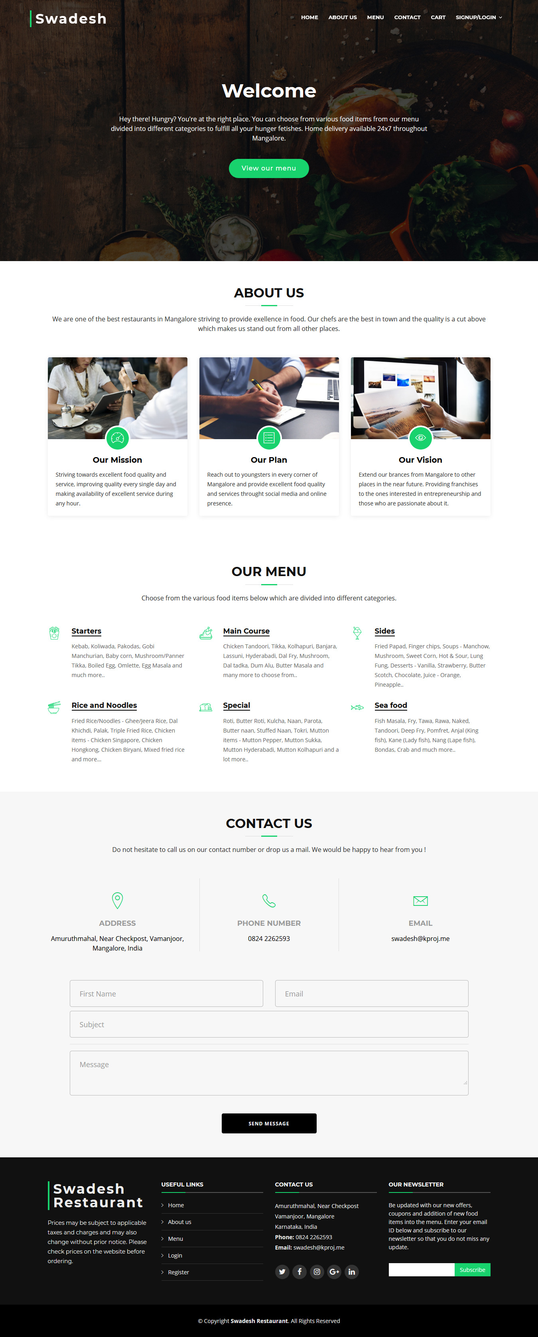

1. **Conclusion**

Project Outcome:

This project enabled the restaurant to deliver its food products to its customers seamlessly at any time of their choice. Online food ordering mediators like Swiggy, Zomato do not operate after 12 AM, but this project enabled the restaurant to deliver food even after midnight.

The restaurant achieved independence in choosing its own pricing and own way of operating. They weren’t forced to apply discounts like how it happens when operating with the mediators.

1. **References**

[www.ieee.org](http://www.ieee.org)

[www.stackoverflow.com](http://www.stackoverflow.com)

[www.wireframe.cc](http://www.wireframe.cc)

developer.paytm.com